 | 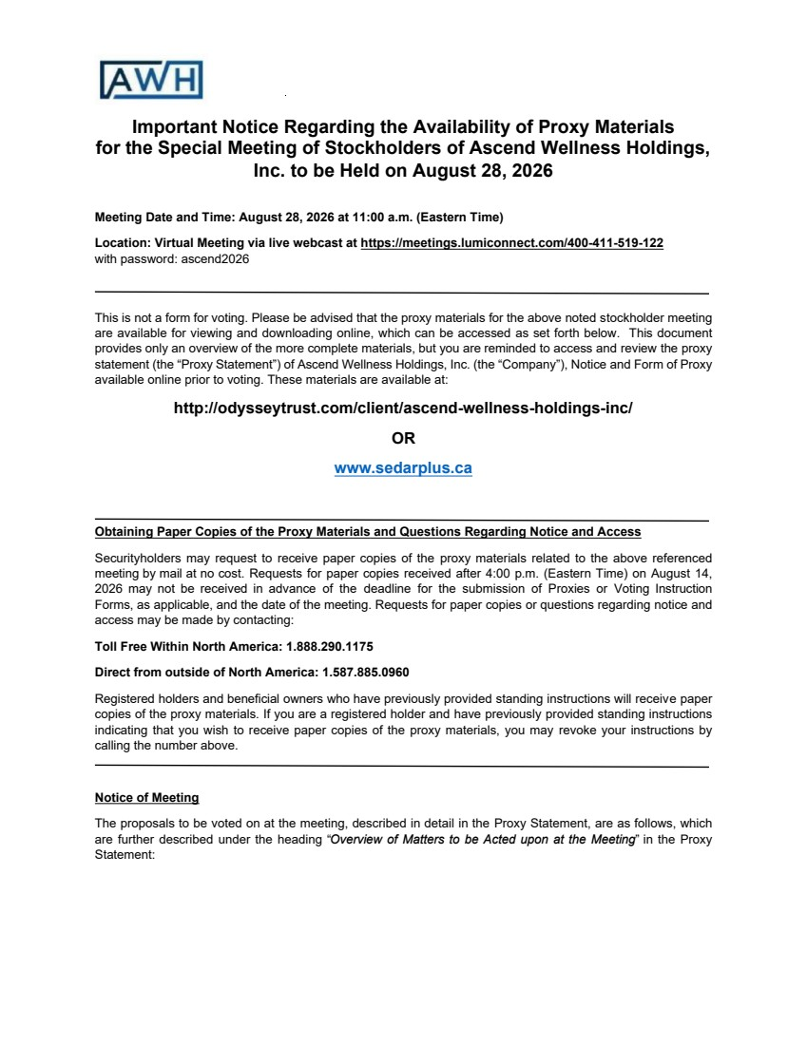 | Important Notice Regarding the Availability of Proxy Materials for the Special Meeting of Stockholders of Ascend Wellness Holdings, Inc. to be Held on August 28, 2026 Meeting Date and Time: August 28, 2026 at 11:00 a.m. (Eastern Time) Location: Virtual Meeting via live webcast at https://meetings.lumiconnect.com/400-411-519-122 with password: ascend2026 This is not a form for voting. Please be advised that the proxy materials for the above noted stockholder meeting are available for viewing and downloading online, which can be accessed as set forth below. This document provides only an overview of the more complete materials, but you are reminded to access and review the proxy statement (the “Proxy Statement”) of Ascend Wellness Holdings, Inc. (the “Company”), Notice and Form of Proxy available online prior to voting. These materials are available at: http://odysseytrust.com/client/ascend-wellness-holdings-inc/ OR www.sedarplus.ca Obtaining Paper Copies of the Proxy Materials and Questions Regarding Notice and Access Securityholders may request to receive paper copies of the proxy materials related to the above referenced meeting by mail at no cost. Requests for paper copies received after 4:00 p.m. (Eastern Time) on August 14, 2026 may not be received in advance of the deadline for the submission of Proxies or Voting Instruction Forms, as applicable, and the date of the meeting. Requests for paper copies or questions regarding notice and access may be made by contacting: Toll Free Within North America: 1.888.290.1175 Direct from outside of North America: 1.587.885.0960 Registered holders and beneficial owners who have previously provided standing instructions will receive paper copies of the proxy materials. If you are a registered holder and have previously provided standing instructions indicating that you wish to receive paper copies of the proxy materials, you may revoke your instructions by calling the number above. Notice of Meeting The proposals to be voted on at the meeting, described in detail in the Proxy Statement, are as follows, which are further described under the heading “Overview of Matters to be Acted upon at the Meeting” in the Proxy Statement:
 | 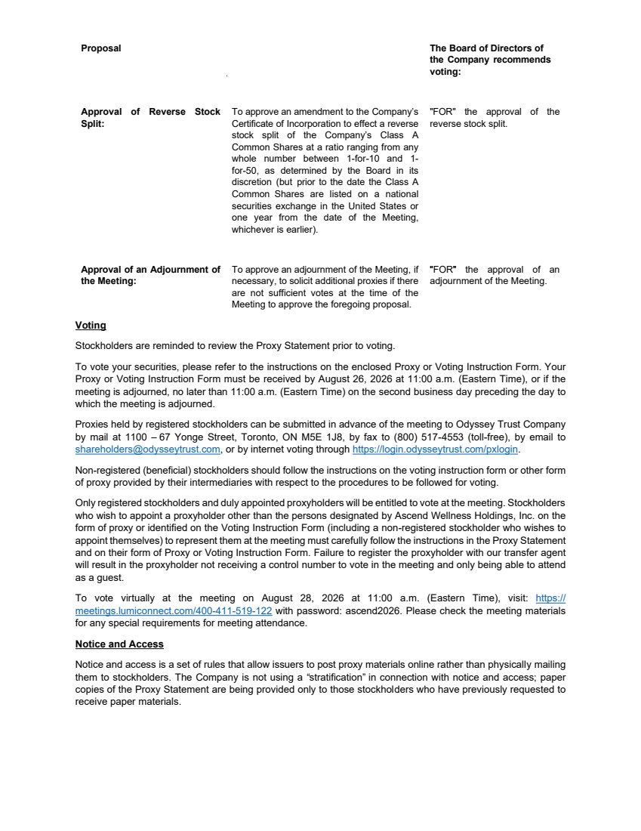 | Proposal The Board of Directors of Approval of Reverse Stock Split: To approve an amendment to the Company’s Certificate of Incorporation to effect a reverse stock split of the Company’s Class A Common Shares at a ratio ranging from any whole number between 1-for-10 and 1- for-50, as determined by the Board in its discretion (but prior to the date the Class A Common Shares are listed on a national securities exchange in the United States or one year from the date of the Meeting, whichever is earlier). the Company recommends voting: "FOR" the approval of the reverse stock split. Approval of an Adjournment of the Meeting: To approve an adjournment of the Meeting, if necessary, to solicit additional proxies if there are not sufficient votes at the time of the Meeting to approve the foregoing proposal. “"FOR”" the approval of an adjournment of the Meeting. Voting Stockholders are reminded to review the Proxy Statement prior to voting. To vote your securities, please refer to the instructions on the enclosed Proxy or Voting Instruction Form. Your Proxy or Voting Instruction Form must be received by August 26, 2026 at 11:00 a.m. (Eastern Time), or if the meeting is adjourned, no later than 11:00 a.m. (Eastern Time) on the second business day preceding the day to which the meeting is adjourned. Proxies held by registered stockholders can be submitted in advance of the meeting to Odyssey Trust Company by mail at 1100 – 67 Yonge Street, Toronto, ON M5E 1J8, by fax to (800) 517-4553 (toll-free), by email to shareholders@odysseytrust.com, or by internet voting through https://login.odysseytrust.com/pxlogin. Non-registered (beneficial) stockholders should follow the instructions on the voting instruction form or other form of proxy provided by their intermediaries with respect to the procedures to be followed for voting. Only registered stockholders and duly appointed proxyholders will be entitled to vote at the meeting. Stockholders who wish to appoint a proxyholder other than the persons designated by Ascend Wellness Holdings, Inc. on the form of proxy or identified on the Voting Instruction Form (including a non-registered stockholder who wishes to appoint themselves) to represent them at the meeting must carefully follow the instructions in the Proxy Statement and on their form of Proxy or Voting Instruction Form. Failure to register the proxyholder with our transfer agent will result in the proxyholder not receiving a control number to vote in the meeting and only being able to attend as a guest. To vote virtually at the meeting on August 28, 2026 at 11:00 a.m. (Eastern Time), visit: https:// meetings.lumiconnect.com/400-411-519-122 with password: ascend2026. Please check the meeting materials for any special requirements for meeting attendance. Notice and Access Notice and access is a set of rules that allow issuers to post proxy materials online rather than physically mailing them to stockholders. The Company is not using a “stratification” in connection with notice and access; paper copies of the Proxy Statement are being provided only to those stockholders who have previously requested to receive paper materials.

